**DATA MANAGEMENT IN HEALTHCARE**

Data visualization and data analytics using Tableau and WEKA

Tejas Parghi – 21505016

Module leader- Dr. Ikram ur rehman

School of computer engineering university of west London.

June 09, 2022

Declaration:-

This report has been prepared on the bases of my own work, where other published articles and other sources have been used, these have been acknowledged.

Student name: Tejas Parghi

Date of submission:- 10th June.

Signature:- Tejas Parghi

Abstract:

information is being used increasingly more due to the fact it's so vital in each corporation and in respective industries. From retail stores to high-quit corporations, pharmacies to top class drug manufacturers., The fact is each person is using and analyzing facts to extract applicable data that would assist them gain profitability. in this report, I have highlighted the value of facts and the manner it's far converting the area. I have performed the dataset from covid-19 vaccination drive and I have also checked out numerous datasets and chosen from NHS official website and the will try to visualized how communitive data could help to predict accurate data analysis with the help of Tableau data visualization software where, different visualization results will be delivered using plenty of methods.

Table of content: -

1. Introduction…………………………………………………….. 5
2. Main body…………………………………………………………7
3. Literature review………………………………………………8
4. Case studies……………………………………………………..10
5. Methodology…………………………………………………….12
6. Result and analysis……………………………………………20
7. Conclusion and future works……………………………..22

# Introduction

Tableau is one of the popular data visualization tool. This is widely used for analyzing the data and financial intelligence. The Gartner’s Quadrant of magic classified the tableau as an industry leader which is used for the analytics and business intelligence purpose. Actually, it is modern business intelligence in the business platform which is used to manage the data and transfer it faster and discover the data and also share it faster to change a revolution in the business world. Everything which is done here, their mission is to understand the data. The data is designed for the data analyst, data scientist and the teacher or the student and also for the business users. From the starting tableau the most powerful platform is this case of data sharing and managing the data. From the connection through the collaboration, it is actually the most powerful and also securable and flexible from top to end analytics platform. In the business purpose it helps to do many works is the case of data transfer so it helps to transfer the data very faster in healthcare purpose and all users are get benefits in this case to managing data or transfer the data. For this it is very important and usable in the healthcare platform.

statistics is the most critical asset for a company and for an organization can leverage for increase in modern-day commercial agency global. but, just because of the fact a higher official recognizes the value extremely-contemporary information, it does not guarantee they may be actively the use of it to increase the productivity of their organization. To get the maximum out current-day any market improvement, clients want to be proactive, and tableau software lets in them to make improvements to techniques and which provides brand new curve in the field of data analytics.

# Aim

The main aim of the research is the proper data Visualization of the global Health Care system with the application of different database Management software. For this reason, some data sets are gathered from the different online sources and implemented in the Tableau to identify the key issues in the health care systems.

.

# Objectives:

* To help the organization of healthcare become more data driven.
* To get the healthcare industries more data visualizing and analyzing the data.
* To classify the data and evaluate the data.
* To understand and identify useful and understandable patterns from the set of data in healthcare.

# Main body of report:

Tableau helps to lead any organization through the change starts with information and data. this software helps in the data digitization and data culture of different modern healthcare organization. It help any organization to make valuable decisions with attitude with the help of visual analytics. This tableau software not only developed the bottom line of any healthcare organization but also improve the quality and health of patient’s life. It also allow the users to connect or interact with the help of data visualizations tool to draw insights from information and also understand it in better way. The healthcare professionals can developed their interaction and also understand the requirement of patients and also make any decisions very efficiently by the use of tableau dashboard (Ligade *et al* 2022). This software also help to understand the main causes of carrier denials and delay in healthcare organization and this type of data used to developed the performance of carrier and also decreases the total cost of any healthcare organization. It also used to predict the goals in future and also used to monitor the availability of carriers. Tableau is used to know about the wait times of patients and also improve the satisfaction of them. This tableau software is very effective in the pandemic situation of covid 19 and it helps to see the spread range of virus and how much people are affected by this corona virus and the number of deaths per day in each country and this is the main scale to understand the spreading range and scale of outbreak (Ko  *et al* 2018.).It also tracks the statistics level of vaccination and it also track the number of people who are unvaccinated. It also helps to detect abuse, fraud, and waste in the healthcare organization. Nowadays privacy of data is very important in healthcare centers due to cybercrime for this purpose the tableau software is used to protect data and also improve the security of the data and information of patients. Weka is also powerful software to develop the models of machine learning.

# Literature Review: -

Visual analytics tools and techniques: -

The term "seen analytics" (VA) became first used within the literature 15 years in the beyond. It refers to a semiautomated technique to statistics processing this is guided via users who can interact with facts thru an interface. In essence, VA converts extensive volumes of quantitative or qualitative information into graphical codecs that can be customized in line with the needs of the operator. users from a selection of backgrounds can utilize the resulting perspectives to higher comprehend statistics, provide a reason behind effects, and disseminate information throughout a great variety of disciplines. (Chishtie et al., 2019).

Visual analytics in healthcare: -

During the last decade, VA deployment and utilization has exploded in an expansion of health-care settings. health offerings studies (HSR) examine the operation of the health care gadget and its staff in connection to get right of entry to, fees, and patient results, whilst population fitness research examines records regarding health effects and determinants for the duration of and among populations. every discipline entail analyzing large quantities of information, which encompass facts gathered from scientific databases, administrative records gadgets, or digital fitness records (EHRs). customers of fitness data, which incorporates physicians, researchers, choice makers, and clients, can utilize VA to visually check and realize complicated records units if you want to assist selection making and expertise discovery. (Chishtie et al., 2019).

Health intelligence using choropeth maps:-

Tableau Public can build many diverse kinds of maps with geographical place names or ISO codes it already is familiar with, consisting of nations, states, counties, and airports, and the adoption and usage of VA has blossomed in masses of fields. Tableau Public, however, isn't able to geocode avenue addresses, therefore you could want to accumulate their latitude and longitude the use of a one among a kind device. Tableau Public has an ability to construct a wide range of maps of maps primarily based on geographical location names or ISO codes that it already recognizes, along with international locations, states, counties, and airports.Tableau Public, however, is not able to geocode street addresses on its very own. (SUKRAINI, YASA and WIGUNA, 2022).

# Case studies: -

1. How Data Visualization and Analytics Helped Frederick Memorial Hospital Improve Performance Metrics: -

locating a better manner to visualize data become a top goal for Frederick Memorial health center. Their quest commenced with the improvement of a model that would organize and visualize facts proper into a beneficial, person-friendly device.  
Tableau had been used as an accurate tools as in to help with their requirements. Tableau shows groups how performance measurements relate to the medical institution's desires, at the same time as also supplying pleasant measures and scientific consequences in a single region. crew individuals may additionally cognizance their efforts on including fee even as remaining assured that the hospital is on target to fulfil its targets.  
  
Emergency services, inpatient and outpatient admissions and discharges, OR management device, time and attendance metrics, and middle high-quality indicators are the important thing additives of Tableau which are being implemented at Frederick Memorial. teams are currently growing benchmark objectives to compare their overall performance to that of peer groups.

1. Lenovo Inc, India:-

Lenovo permits self-provider analytics, which allows every person to behavior their private analysis on a hard and fast of facts according to their vicinity of activity and location duties. Tableau clients have identity credentials saved in the business enterprise's close by identity keep, which they may use to access and art work on Tableau dashboards thru a unmarried signal-on method.Lenovo's e-trade business enterprise grew appreciably because of its use of Tableau to evaluate purchaser experience the usage of facts from Lenovo's unified consumer intelligence platform, LUCI Sky.

# Methodology of tableau: -

Datasets: -

Here I have selected the database from the NHS’s official website about COVID-19 vaccination studies based on different community group. This dataset includes a summary of the type community which had been involved in this drive conducted by NHS Where this community information also includes the type ethnicity which were associated with this study.

Website- <https://digital.nhs.uk/dashboards>

File - Coronavirus_Vaccine_Studies_Volunteers_Open_Data.csv

Below, I have followed the mentioned steps to conclude this project.

**Dimensions and measures: -**

Tableau has a concept of measures and dimensions that you can use to classify variables.  
even as running with them, however, it is easy to get the 2 mixed up.  
in spite of the reality that users may trade a few fields from degree to measurement or vice versa, there may be a big difference some of the as a manner to impact your visualization.  
permit's start by using the use of going over the definitions of whenever duration.

A field that may be aggregated in a few styles, such as a sum or a mean, is known as a degree. consider it something that can be collected, tallied, or mixed to offer a single price.

A size is a discipline that can be used to divide or degree every different field into organizations. it could be used to specify the amount of detail on which an aggregate want to be finished. for example, use the Sum of income as a degree after which use location as a dimension discipline to divide the Sum of sales into the Sum of income regular with place.

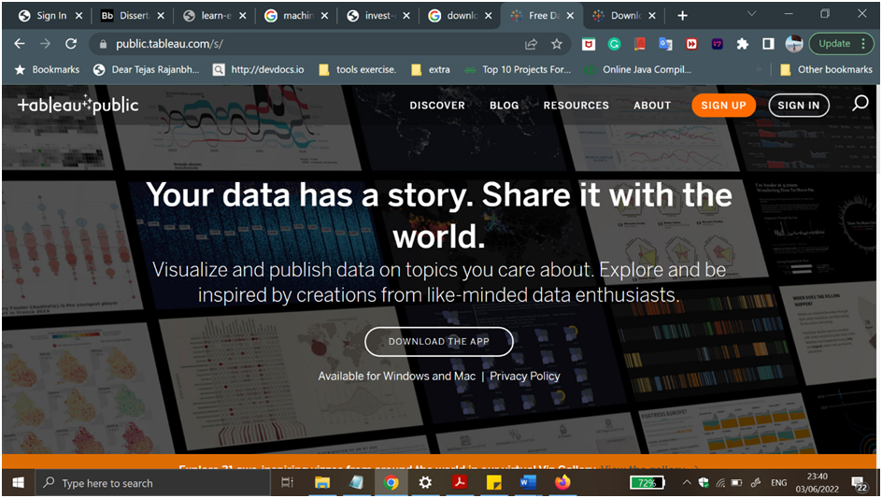

**Figure 1: Tableau public official website.**

(Source: tableau)

* At first, open the browser and go to the search button and type the tableau and find the tableau official page and open it.

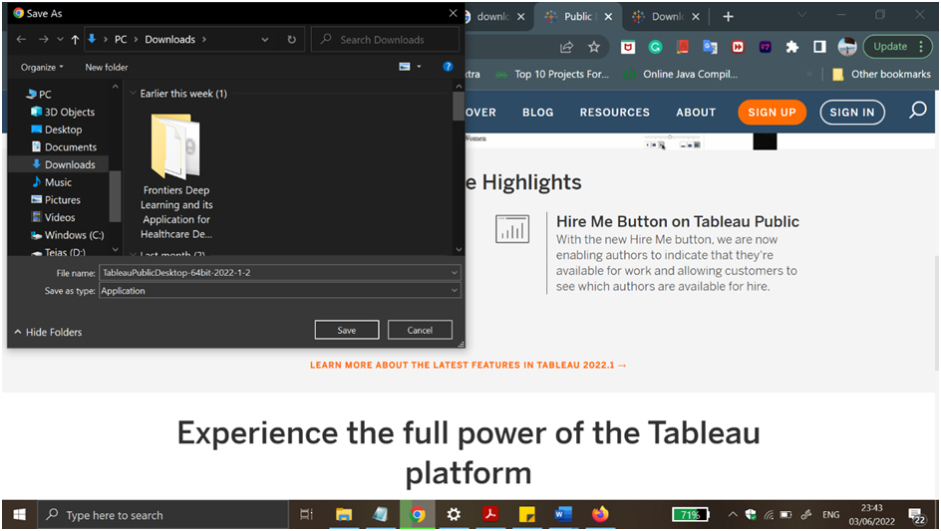

**Figure 2: Downloading of installing wizard of the tableau.**

(Source: tableau)

* After opening the official page of the tableau then go to the downloading process and then go to the installing process in the system. After downloading the tableau, next go to the wizard of tableau and install the whole process and then use the platform for healthcare purposes and get the benefit of this software in the medical platform.

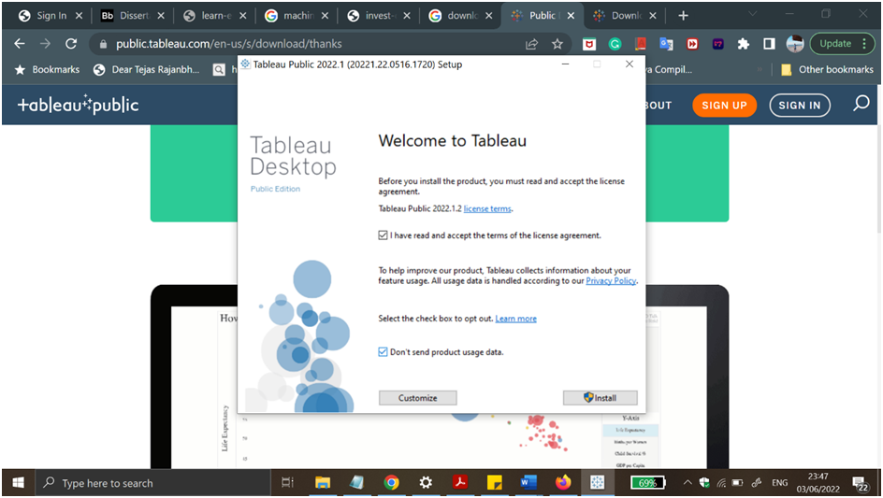

**Figure3: License agreement wizard**

(Source: Tableau)

* After completing the download and installing process then the license of the software is obtained and permitted to open the software and use the software for healthcare purposes. After getting the license agreement then it is able to work in case of data transferring, analyzing and data management and many other purposes also. In healthcare the purpose is very carefully driving the data and easily identifying and understanding data patterns. 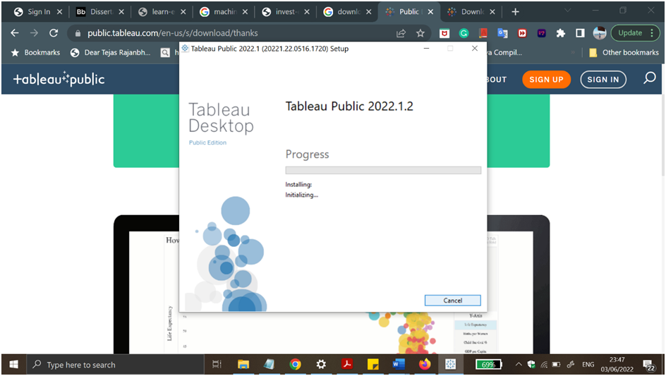

**Figure 4: Installing process of the tableau.**

Source: tableau

* After getting the license agreement of wizard then the last and final process is installation. Completing the all process then the installation of the software is very important to work on it. This process is very important and important when software is installed (Billur *et al* 2019).

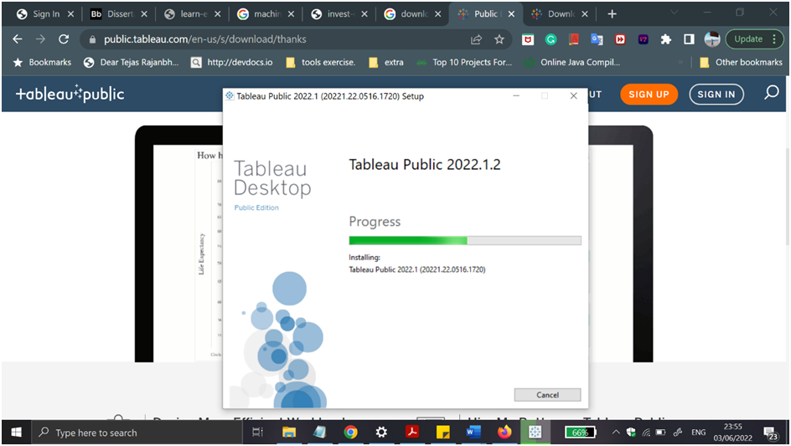

**Figure 5: Running the process of installation in tableau.**

(Source: Tableau)

* In this picture the tableau software installation process running which is shown in a green highlighter (Seun *et al* 2019). The meter indicates how much time is left to install the software and how much software installation is done in the case of tableau installation process. It is also an important process of this part of installing (Krithika *et al* 2020).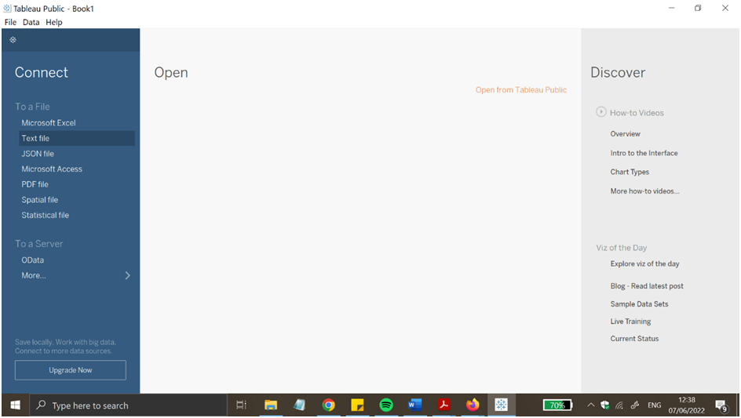

**Figure6: Tableau front interface**

Source: Tableau

* In this snip seen the tableau is successfully open and ready to work, which is the most important part of software to open the front part or the face of the software (Ratra *et al* 2020). After seeing the front page then users do the other types of data related work for the healthcare purpose and get the benefits.
* 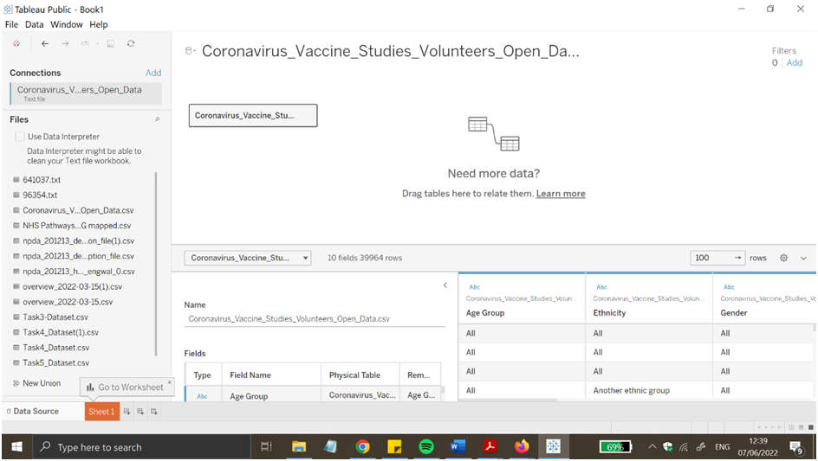
* **Figure 7: importing dataset in worksheet of tableau**
* Source: tableau
* After that the dataset is imported in the worksheet of the tableau to get the informative result from the software about the vaccinated people (Ko, I. *et al* 2018.).
* 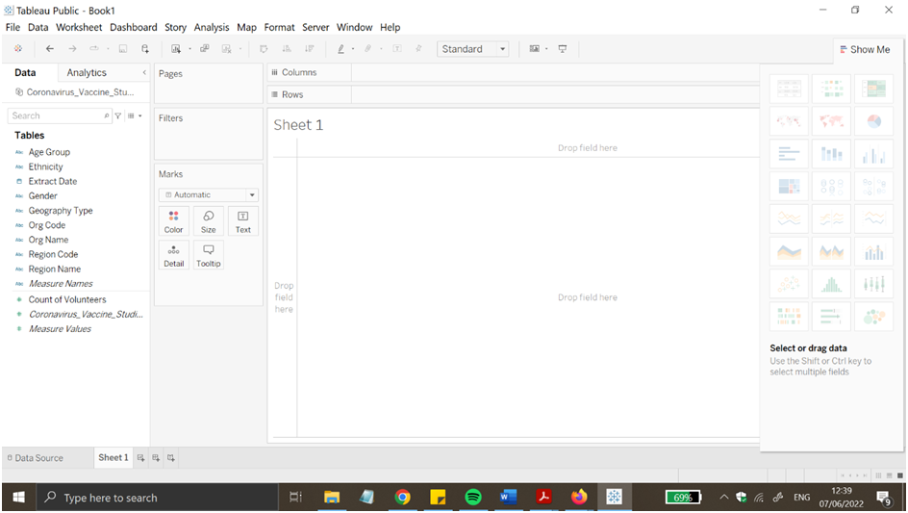
  + - * Figure 8: Tableau console

# Results and Analysis

## Tableau

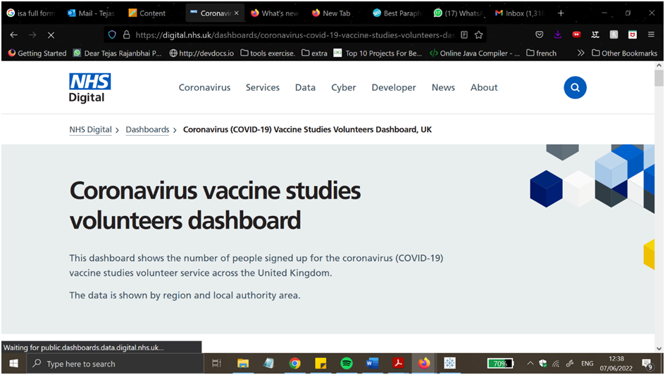

**Figure7: dataset source used from NHS**

(Source: tableau)

Here a dataset is used from the NHS which is based on corona virus. Here the dataset is a study about the vaccine of corona virus (Jena et al. 2019). The data set is used for the vaccination process of the community and to get the rate of vaccination among the people. Using the tableau the total dataset of corona virus vaccine comes out.

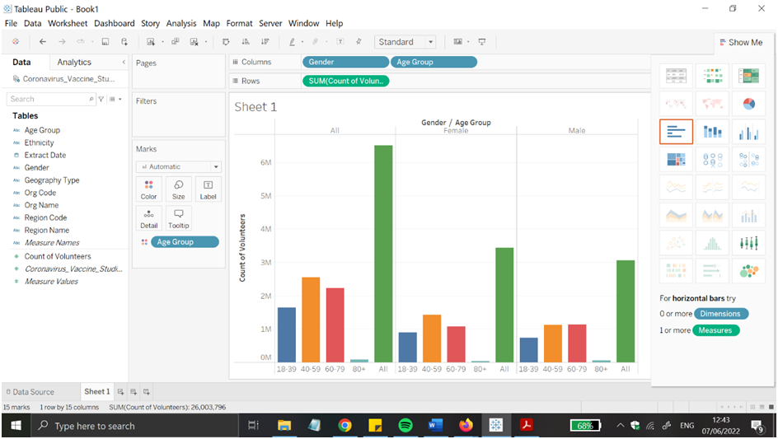

**Figure10: Dashboard and graph representation number of took part in volunteer in this vaccine drive which separate the gender groups**

(Source: tableau)

Here the dashboard is shown and the graph is plotted which separates the gender groups in the vaccination.

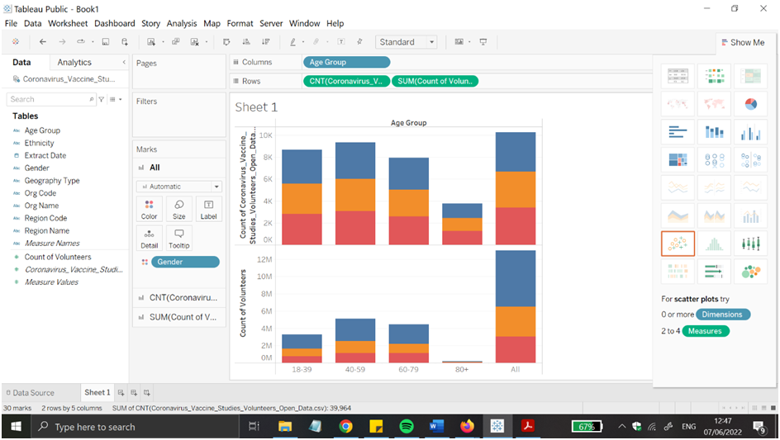

**Figure11: Bar graph showing the age group involved in the vaccination process**

Source: tableau

Here is this graph indicating the age group of the vaccinated people and divide in the other bar to easily identify how many people were vaccinated age wise(Firdaus *et al* 2018.).

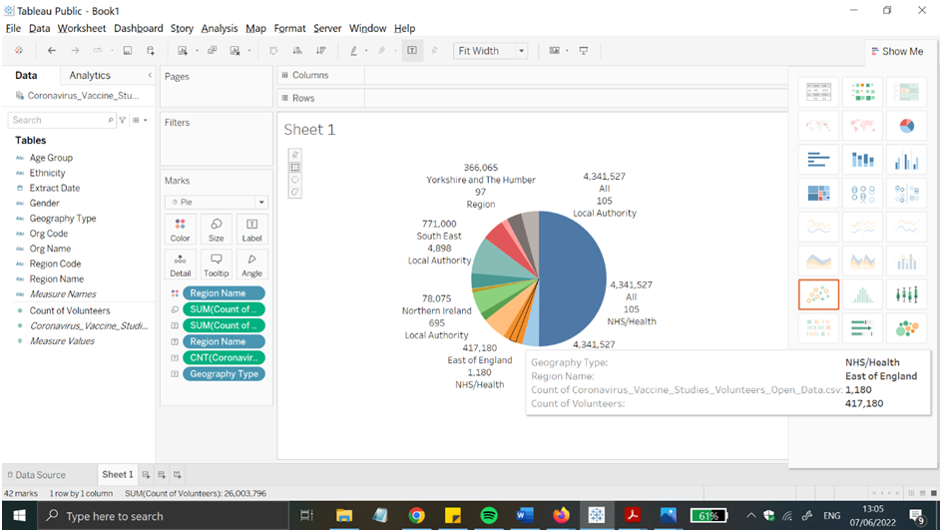

**Figure12: Pie chart showing different region of the UK**

Source: Tableau

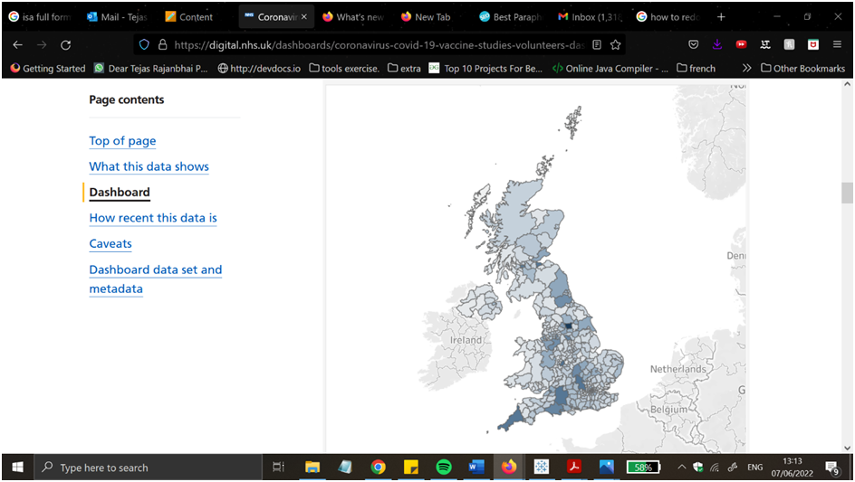

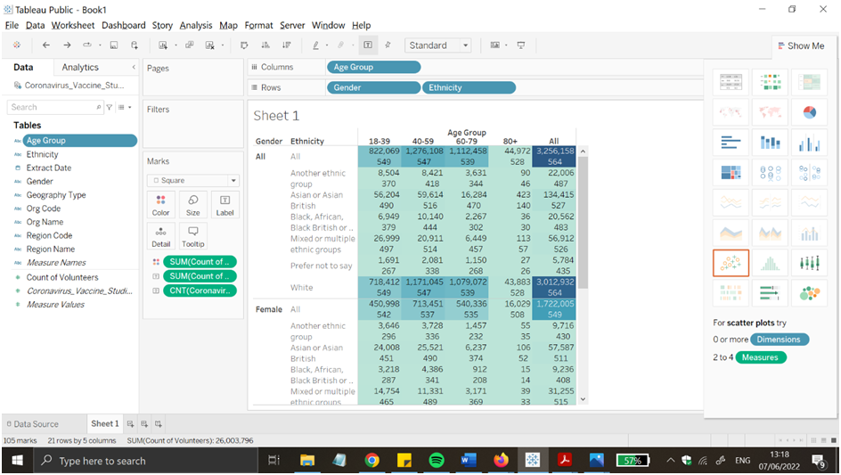

**Figure13: Table showing the amount volunteer involved from different ethnicity part1**

Source: Tableau

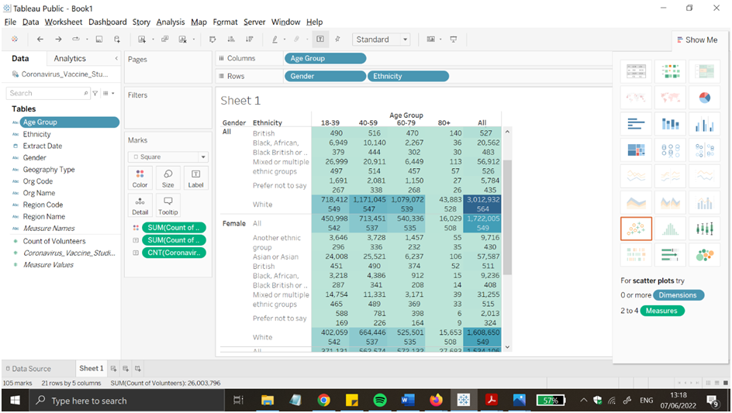

**Figure14: Study from different ethnicity part 2**

Source: Tableau

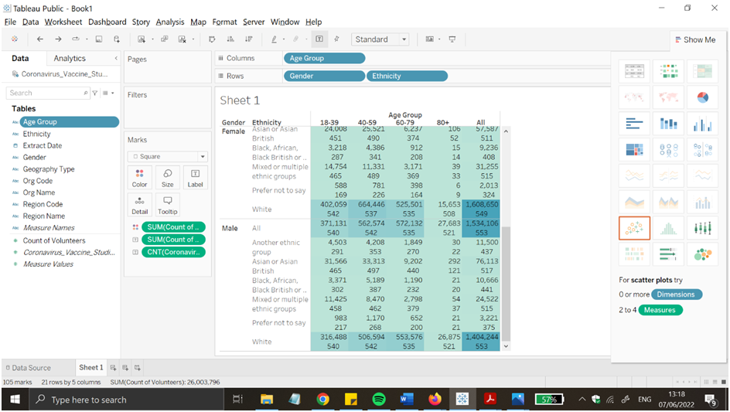

**Figure15: Study from different ethnicity part 3**

Source: tableau

In these three parts showing the amount of volunteers involved in this part of study from different ethnicities.

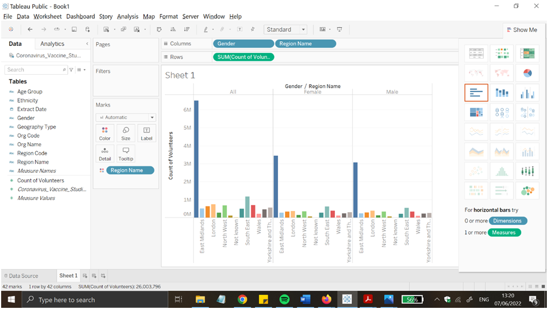

**Figure16: Bar graph depicting region wise of participation of volunteer in the UK**

Source: Tableau

Here the bar graph is plotted in the tableau software which was defined to depict region wise participation of volunteers in the UK (Firdaus  *et al* 2018.).

# Conclusion and Future Work:-

Tableau is a very important and effective tool for the graphical representation and it has mostly twenty-four graphical views to display the in front the user. On the other hand, weka is also more effective and important in the purpose of machine learning, classification association, and visualization of data in the purpose of data management in the healthcare field.

I have attempted to extract extra facts from the dataset in the future using a complicated query so as to offer us with a high-quality understanding of the facts. To make this dataset more applicable, I may additionally add the most modern-day statistics from numerous hospitals that offer Covid19 vaccinations, making the dataset extra robust and beneficial. in addition, i will work to raise cognizance among hospitals about the significance of information manipulate, on the way to have a quality have an effect on.

## 

# Reference list:

**Journal**

Jena, B., 2019. An Approach for Forecast Prediction in Data Analytics Field by Tableau Software. *International Journal of Information Engineering & Electronic Business*, *11*(1).

Ligade, V.S. and Chimegave, A., 2022. Analysis of the literature on 3D printing in healthcare with reference to pharmaceuticals using a bibliometric approach. *Journal of Applied Pharmaceutical Science*, *12*(3), pp.096-102.

Ko, I. and Chang, H., 2018. Interactive data visualization based on conventional statistical findings for antihypertensive prescriptions using National Health Insurance claims data. *International Journal of Medical Informatics*, *116*, pp.1-8.

Vasundhara, S., 2021. Data Visualization View with Tableau. *Stochastic Modeling and Applications*, *25*(1), pp.178-187.

SUKRAINI, T.T., YASA, I.M.A. and WIGUNA, P.P.K. (2022). COMPARING CHOROPLETH AND GRADUATED SYMBOLS: HOW DIFFERENT MAP TYPES AFFECT PUBLIC UNDERSTANDING IN COVID-19 MAP READING IN BADUNG REGENCY, BALI, INDONESIA. *Geographia Technica*, 17(1/2022), pp.150–166.

S Krithika, D.R. and Rohini, K., 2020. A Survey on Challenging Capabilities of Big Data Analytics in Healthcare. *International Journal of Innovative Research in Applied Sciences and Engineering*, *4*, pp.593-597.

Saleh, B., Saedi, A., Al-Aqbi, A. and Salman, L., 2020. Analysis of Weka Data Mining Techniques for Heart Disease Prediction System. *International journal of medical reviews*, *7*(1), pp.15-24.

Firdaus, H., Hassan, S.I. and Kaur, H., 2018. A Comparative Survey of Machine Learning and Meta-Heuristic Optimization Algorithms for Sustainable and Smart Healthcare. *African Journal of Computing & ICT,(11)*, *4*, pp.1-17.

Chishtie, J.A., Babineau, J., Bielska, I.A., Cepoiu-Martin, M., Irvine, M., Koval, A., Marchand, J.-S., Turcotte, L., Jeji, T. and Jaglal, S. (2019). Visual Analytic Tools and Techniques in Population Health and Health Services Research: Protocol for a Scoping Review. *JMIR Research Protocols*.‌

‌

Part B

**DATA MANAGEMENT IN HEALTHCARE**

**Abstract:-**

This report provides insights of WEKA, an open source data Mining software program programme built in Java that can be discovered at www.cs.waikato.ac.nz/ml/WEKA/. The workshop's purpose is to illustrate WEKA's fundamental talents, which can be utilized in undergraduate laptop era and engineering guides. WEKA gives a robust set of machine mastering algorithms for data Mining jobs, as well as a whole kind of gear for records pre-processing, analytics, and visualisation, all on hand through a simple graphical user interface. WEKA is a famous instructional software program for data mining. utilized several supervised machine learning algorithms in building a model to analyse and predict the presence of Breast cancer and Diabetes, using the dataset from Diabetes. J48 Decision Tree, IBK, PART, Zero R and Naïve Bayes algorithms were applied through WEKA machine learning software. Each model’s performance was evaluated using 10-fold cross validation and compared according to major accuracy measures, correctly or incorrectly classified instances.

**Table of content:**

1. Introduction of WEKA……………………………………………………………25
2. Main body……………………………………………………………………………..27
3. Features of WEKA………………………………………………………………….29
4. Literature review…………………………………………………………………..29
5. Case studies…………………………………………………………………………..30
6. Methodology………………………………………………………………………….31
7. Result and analysis…………………………………………………………………40
8. References………………………………………………………………………………42

**Introduction of WEKA.:-**

The WEKA is a flightless bird which has an inquisitive nature which is found on the island of New Zealand. In this case of data collection method WEKA is collection of machine learning algorithms which is for tasks in data mining. It is actually used for classification, regression and association mining and visualization.

The WEKA tool gaining knowledge of Data processing which is a today's highly popular platform for computerized type, regression, clustering, and characteristic selection, which is probably common data statistics mining obligations. It includes a huge style of system getting to know algorithms and facts pre-processing techniques, in addition, it also includes the graphical character interfaces for data exploration and experimental assessment of several system learning techniques at the same topic. WEKA can paintings with information that is organized in an unmatched relational table. Its essential goals are to,

(a) help customers extract important facts from information and

(b) make it easy for them to choose the correct method for developing an powerful predictive model from it.

# Main Body:-

Early detection is vital for stopping the unfold of a ailment that would endanger human lives. COVID-19, a contagious disease that has mutated into more than one sorts, has advanced into a worldwide epidemic that requires immediate diagnosis. With the advancement of technology, the quantity of records to be had on COVID-19 grows each day, and facts mining can be used to extract applicable facts from huge quantities of statistics.

A listing of instances sharing a fixed of traits is described in an ARFF (attribute-Relation document format) file, that is an ASCII textual content record. The system gaining knowledge of project on the university of Waikato's department of laptop era created ARFF documents for use with the Weka tool mastering programme.

WEKA is a Java-based totally set of gadgets mastering algorithms created on the university of Waikato in New Zealand. WEKA's most important feature is to do facts-mining duties, and it changed into first utilized in schools as a getting to know resource. The product is now blanketed in the Pentaho business intelligence suite, which makes use of WEKA for enterprise intelligence. it can be used for a spread of purposes.  
  
-guidelines of the affiliation  
-deciding on a characteristic  
-Clustering  
-Pre-processing of records  
-classification of information  
-Visualization of information  
-evaluation of Regression  
-examine the workflow

**Features of WEKA:-**

1. Preprocessors: -

Preprocessor - A preprocessor is a software program application programmed that cleans up noisy records. It can undertake any additional evaluation if the statistics is noisy. Having said that, It can be that determine what issues are found in statistics; ABT (analyze Base table) in the information may be considered from an excel report, and information records may be found the use of Excel clear out menus. records cleansing, facts integration, records discount, and facts transformation are the four degrees of statistics preprocessing.

1. Classifiers: -

Classifiers- Following the techniques, users could also use the data once it has been preprocessed to obtain some knowledge. a deliberate grouping or categorization of items based on predetermined criteria. There are multiple types of classification techniques.

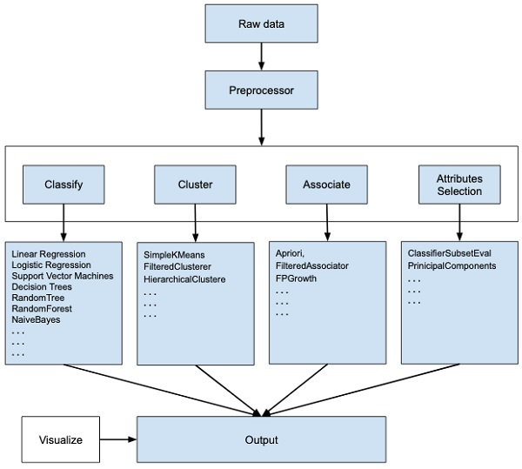

Figure 1 Pre-processor’s classifications.

Source- Mystudylab.com

# Literature review: -

Cardiovascular ailment is a blanket word that consists of a massive range of coronary heart-associated health troubles. The pathological troubles of the coronary heart, further to extraordinary factors of it, are expressly described via such scientific troubles. coronary heart disorder is a serious health problem. The quantity of males and females suffering from coronary heart ailment has risen over time . several research on the therapy of coronary heart illness had been completed. various diagnostic device getting to know algorithms were used, yielding distinctive chances. several research are being carried out to assess the inefficiency of the ok-famous character, J48, SMO, Nave Bayes, MLP, Random forest, Bayes internet, and REPTREE algorithms. simplest in rare times does Bayes net beat random forests, steady with the checks so far. (Srivastava, 2014)

The mathematical processes of Nave Bayes elegance are executed. The possibility precept of the Bayes precept is used to calculate the participation elegance. The Nave Bayes algorithm is based mostly on implicit independence. It refers back to the independence of feature values for a given beauty from one in all a kind function values. For the primary schooling database, the posterior possibility of the response parameter is calculated. the opposite parameters are similarly subjected to structured opportunity computations.

selection timber (J48): The middle of the logistic regression is just like that of a tree, with all inner nodes serving as an exam at the traits and all roots reflecting the available test effects. a couple of function desire metrics beneficial resource in deciding on the feature for information beauty branch. In data mining, various versions of desire timber are utilised. The author has estimated the accuracy of j48 is better then Naive bays.

**Case studies: -**

Health data scoring analysis using WEKA:-

As consistent with past studies, the Government healthcare departments has visible numerous useful improvements inside the twenty-first century. The health organization location makes use of present day-day techniques which includes facts mining to maintain up with new traits and traits in digital technology. the usage of WEKA software for credit score scoring changed into tested on this work the use of a case observes of a German health credit score dataset. consistent with the hypothetical results, there are a greater percent of patient classified as "fit," or those who pay their health tracking rating on time. clients with a bigger balance on their cutting-edge account and who've worked for a prolonged span of time are certainly higher risk, regular with the findings.

# Methodology: --

Dataset: - The datasets selected is related with diabetes patients, The dataset contains the closure of numbers of patients who are currently diabetes positive, with inclusive analysis the patients status on diabetes can be easily predicted by data mining.

In this chant here figure out the data driven of the diabetes patients in the WEKA software process. The chart is excised with serial number, naiveBays cross, J48 cross, and ZeroR cross and INK cross and at the last PART cross.

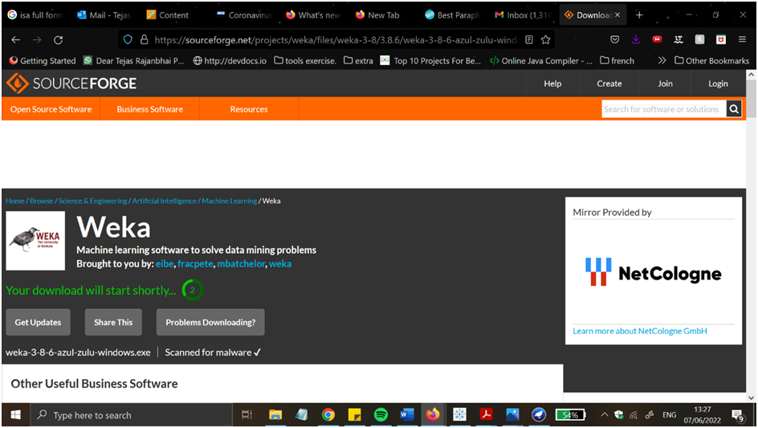

**Figure2: Downloading wizard from the WEKA**

(Source: WEKA)

The first part of using the software WEKA must to do that part, which is downloading the wizard from the WEKA. In this part users know about the whole process of the installation of the software and then go to download it to use the software in their system. Finding the wizard and correctly downloading the software is a very important process (Saleh *et al* 2020) . 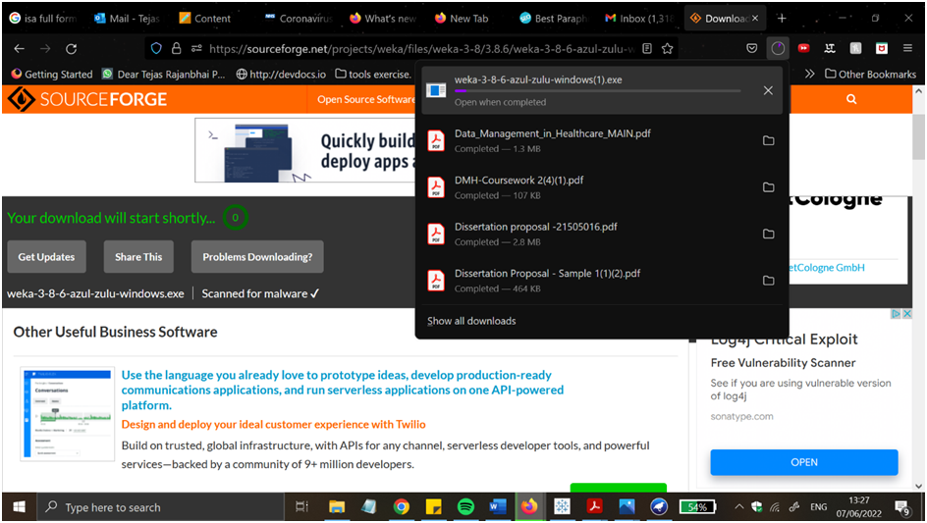

**Figure3: Installing wizard of WEKA**

(Source: WEKA)

Here after downloading the software from the WEKA then completing the downloading process users go to the installing process. Here in this case of installation users are able to click the install option and easily install the WEKA in their system (Vasundhara, S., 2021).

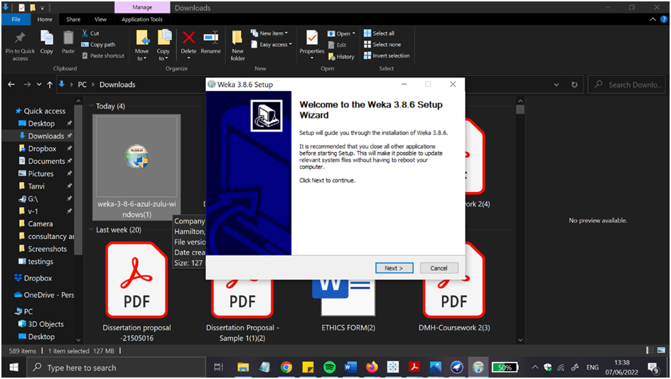

**Figure4: Set up guide of wizard**

(Source: WEKA)

In this case normally the setup guide of the wizard is seen (Sarangam Kodati, D.R.V., 2018). In this process basically told the setup guidance and told about the download process of the software and also told about the software terms and conditions to the users. 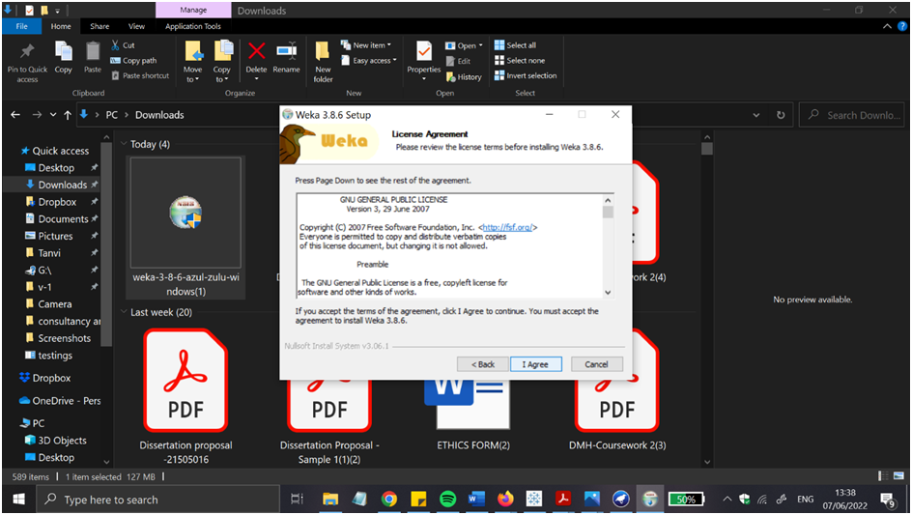

**Figure5: License agreement**

(Source: WEKA)

In this picture after knowing all the terms and conditions the used are go to the I agree button and agree with all the information and step up to get the main facing page of the WEKA software.

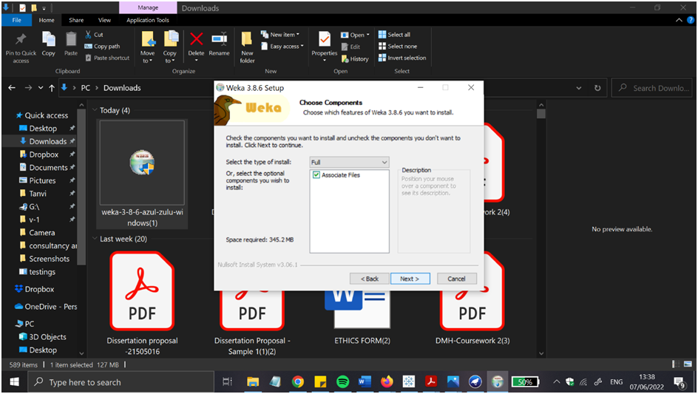

**Figure6: component section**

Source: WEKA

Here the users can see the components of the software and how to use the components to run the app and get the best result. 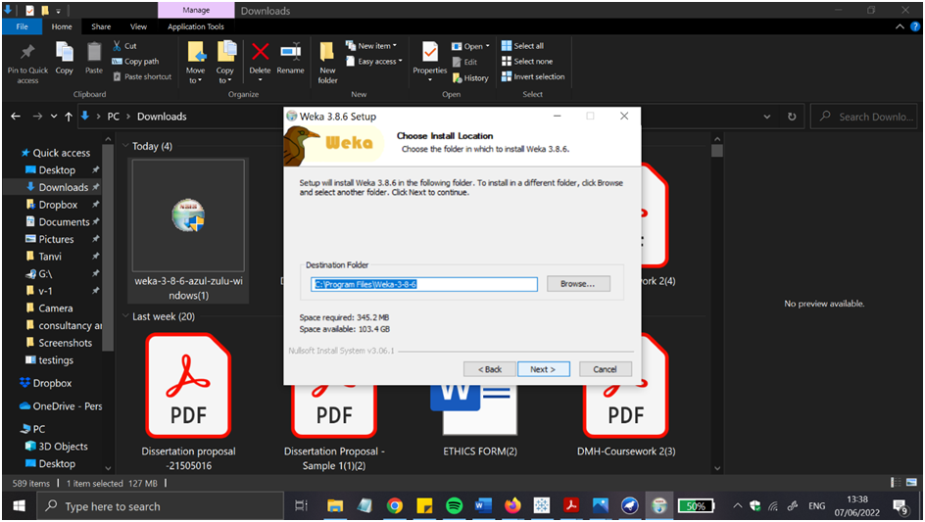

**Figure7: set up of Path section**

(Source: WEKA)

This picture indicates the set up of the path selection of the software WEKA and gets the result while using the software.

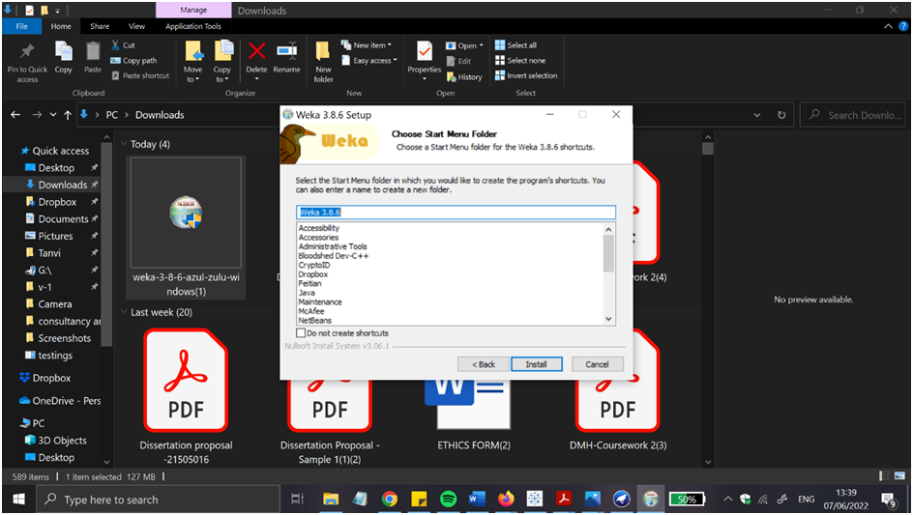

**Figure8: Starting of the menu folder**

(Source: WEKA)

After getting the path selection then the main menu folder is open and users can easily choose the option that the users want in the main menu of the software.



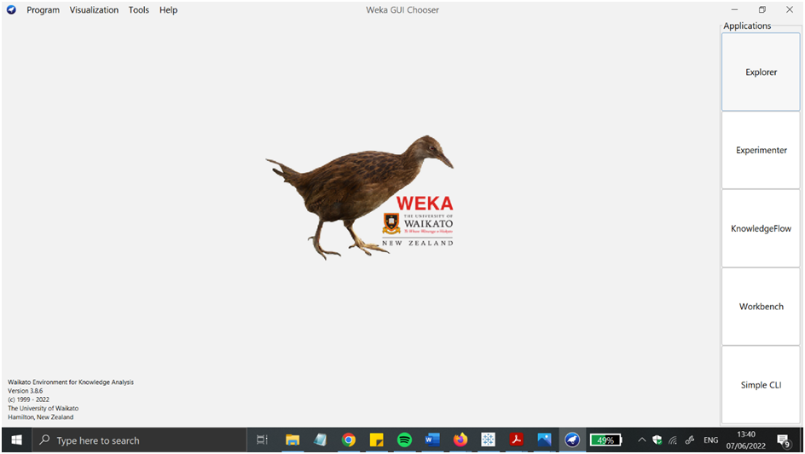

**Figure9: The starting phase of WEKA**

(Source: WEKA)

At the end of the software the main phase of the software comes out and users can easily use the software in the healthcare propose.

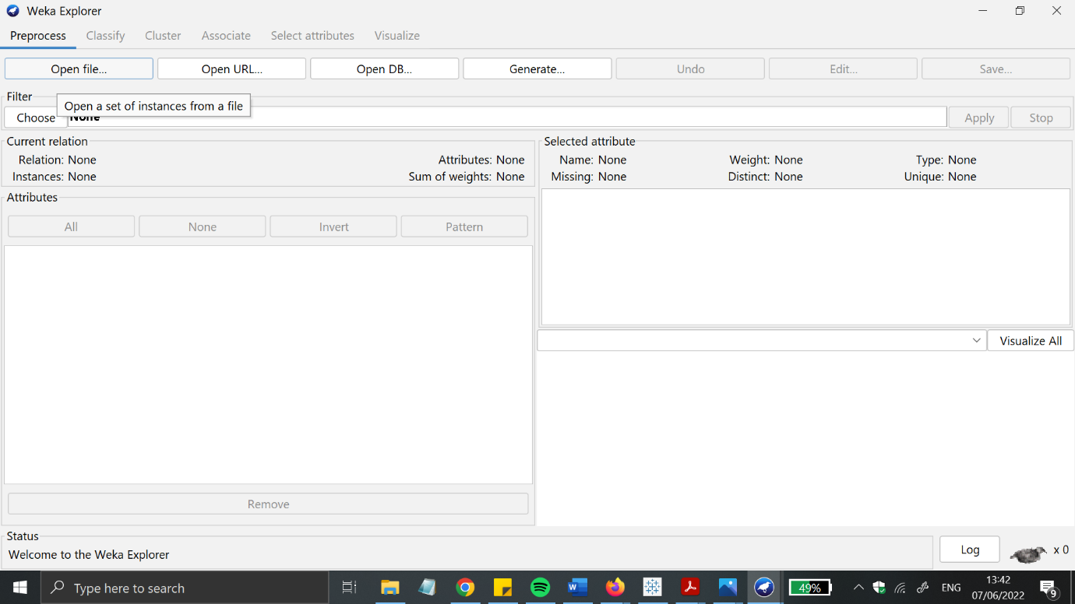Figure 10 WEKA console page.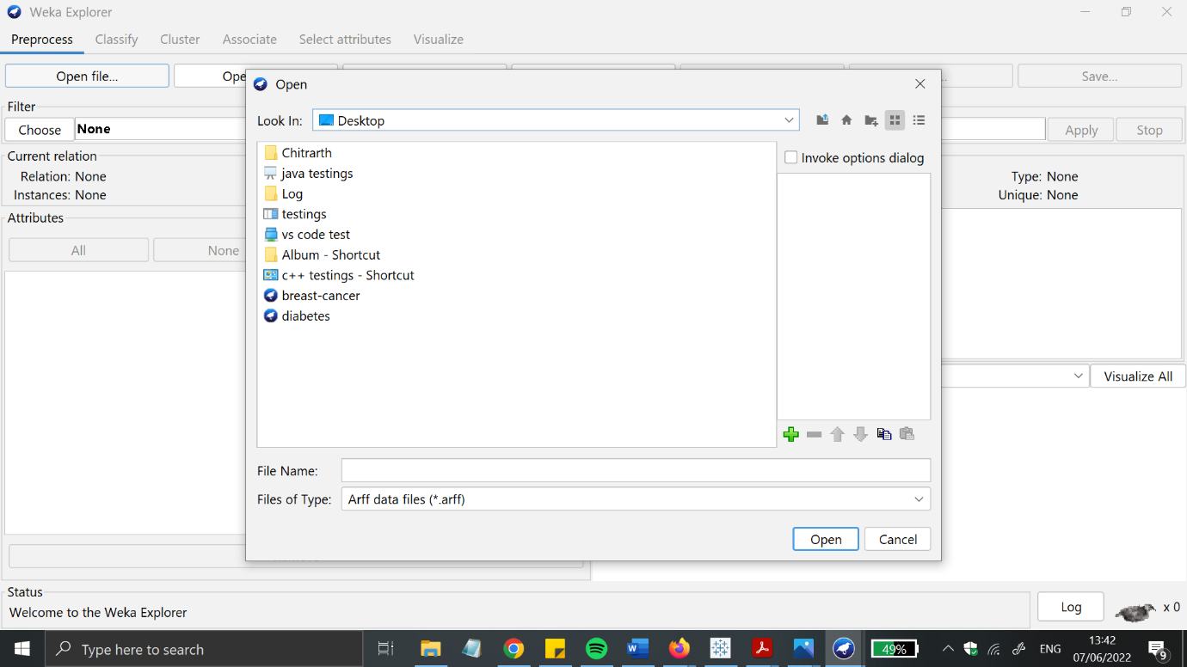Figure 11 importing datasets from source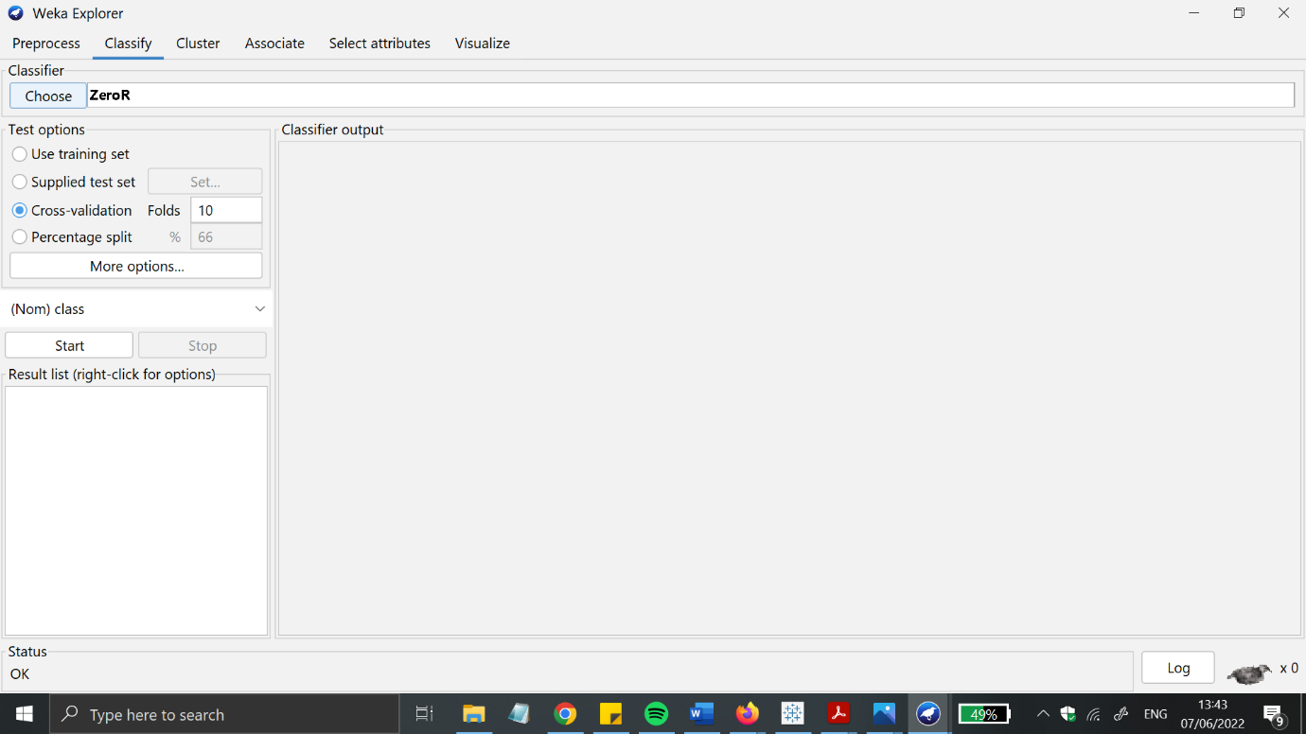Figure 12 analysis performance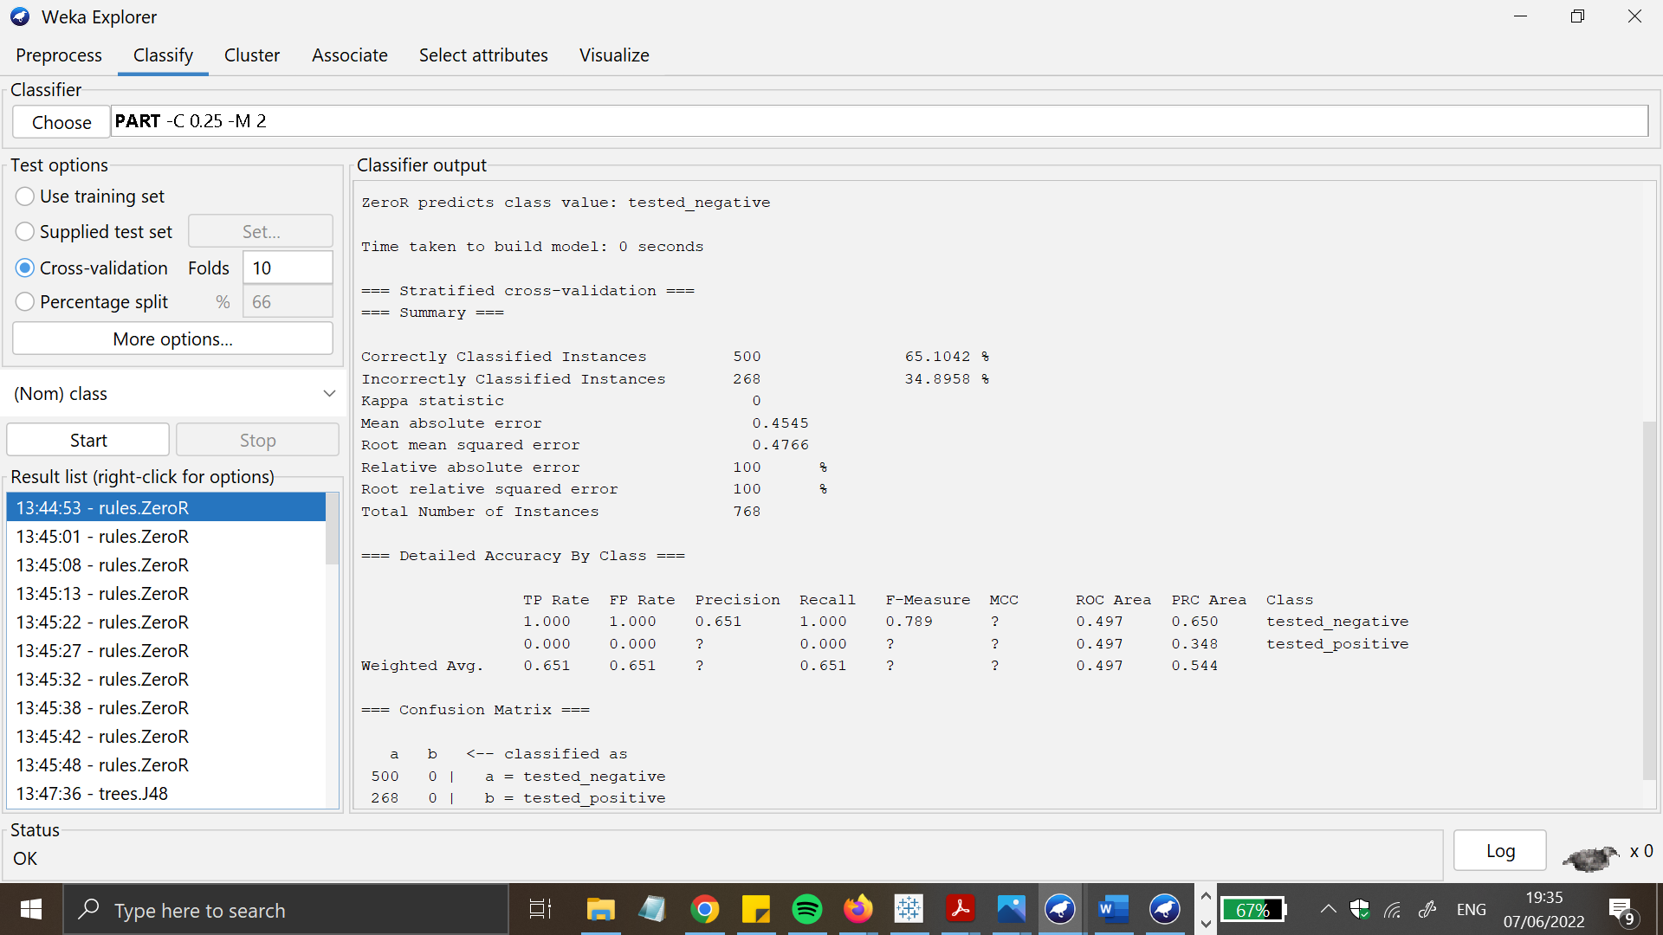Figure 13 Analysis results from 10 cross validation 5 classifiers

**Results and analysis: -**

whilst encoder filters are as compared with regards to time it takes to assemble a format and the variety of accurate examples diagnosed, it is clean that Supervised studying promises tremendous performance. Here, in this below table I have mentioned the results from 10 cross validation results from 5 classifiers.

## WEKA

|  |  |  |  |  |  |
| --- | --- | --- | --- | --- | --- |
| **Sr number** | **NaiveBayes, cross validation 10 folds** | **J48, cross validation 10 folds** | **ZeroR cross validation, cross validation 10 folds** | **IBK cross validation, 10 folds** | **PART cross validation 10 folds** |
| **1)** | **70.2797%** | **72.3776%** | **70.2797%** | **69.9301%** | **65.035%** |
| **2)** | **70.979%** | **72.3776%** | **70.2797%** | **74.1259%** | **66.433%** |
| **3)** | **69.9301%** | **71.3287%** | **70.2797%** | **69.5804%** | **72.3776%** |
| **4)** | **74.1259%** | **72.7273%** | **70.2797%** | **73.0769%** | **70.979%** |
| **5)** | **73.7762%** | **71.6783%** | **70.2797%** | **74.1259%** | **69.9301%** |
| **6)** | **73.0769%** | **73.7762%** | **70.2797%** | **72.3776%** | **72.028%** |
| **7)** | **74.1259%** | **72.7273%** | **70.2797%** | **72.3776%** | **70.2797%** |
| **8)** | **75.5245%** | **72.0283%** | **70.2797%** | **72.3775%** | **71.3287%** |
| **9)** | **75.5245%** | **71.6783%** | **70.2797%** | **72.3773%** | **70.979%** |
| **10)** | **73.0769%** | **72.7273%** | **70.2797%** | **73.4266%** | **69.2308%** |

**Figure17: chart of diabetes patients in WEKA software.**

Source: WEKA

Here in this chart displays the patient ratio which is made from the WEKA software (Firdaus *et al* 2018).

The WEKA is running on the java programming so it can run any system and to work on the large data set and helps automating in the work so in the industry purpose using this the company get more profit in their production and achieve their success in the industrial field.

**Future works and conclusion:-**

operating with the WEKA tool is tested intensive in this paper. we are able to undergo information mining thoughts first, and then the numerous ranges of information mining in Weka. the steps involved in acting several records mining standards are outlined. WEKA's API is extraordinarily useful because it may be used to tweak any set of policies for higher effects.

**References: -**

Journals

Billur, E.C.E.R. and AKTAŞ, A., 2019. Clustering of European Countries in terms of Healthcare Indicators. *International Journal of Computational and Experimental Science and Engineering (IJCESEN)*, *5*(1), pp.23-26.

Ratra, R. and Gulia, P., 2020. Experimental evaluation of open source data mining tools (WEKA and Orange). *Int. J. Eng. Trends Technol*, *68*(8), pp.30-35.

Seun, E., Adekunle, Y.A., Omotosho, O.J., Adebayo, A.O. and Omolara, T., 2019. Data Privacy Preserving Model for Health Information System. *International Journal of Engineering Research and Technology*, *12*(6), pp.745-752.

saleh, B. jumae (2018). APPLYING DATA MINING TECHNIQUES ON ACADAMIC INSTITUTIONAL SYSTEM USING WEKA. *International Journal of Recent Trends in Engineering and Research*, pp.86–88.

Priangga, P. and Suryani, E. (2019). Decision Analysis of Giving Credit Using Pairwise Comparisons and Scoring Methods (Case Study: Bank XYZ). *IPTEK The Journal for Technology and Science*, 30

Srivastava, S. (2014). Weka: A Tool for Data preprocessing, Classification, Ensemble, Clustering and Association Rule Mining. *International Journal of Computer Applications*, 88(10), pp.26–29. doi:10.5120/15389-3809.

arangam Kodati, D.R.V., 2018. Analysis of heart disease using data mining tools Orange and Weka. *Global journal of computer science and technology*.

‌

‌

‌